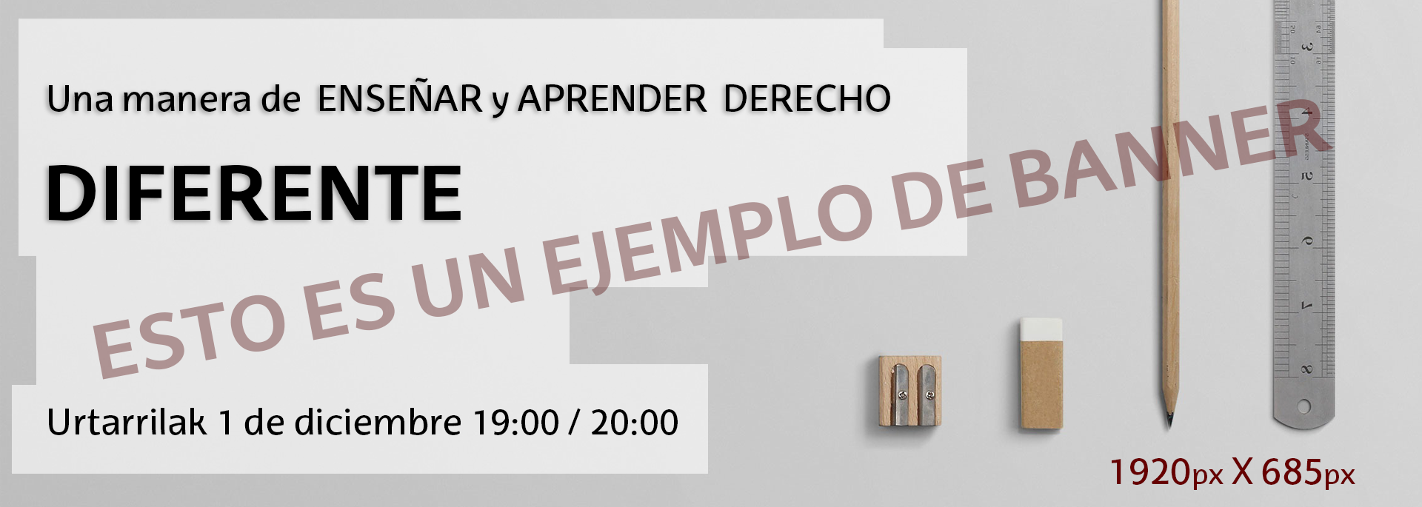
Título 1 de conferencias, jornadas, seminarios etc…
ZOOM BIDEZKO WEBINARRA  2021ko urtarrilaren12a  19:00-20:00  Doako sarbidea aldez aurretik izena emanda  Parte hartzaileak:  • Lorem Ipsum (Madril). simply dummy text of the printing and typesetting industry. Lorem Ipsum has been the industry's standard dummy text ever since the 1500s, when an unknown printer took a galley of type and scrambled it to make a type specimen book. It has survived not only five centuries, but also the leap into electronic typesetting, remaining essentially unchanged. It was popularised in . unknown printer took a galley of type and scrambled it to make a type specimen book.  • Lorem Ipsum (Madril). simply dummy text of the printing and typesetting industry. Lorem Ipsum has been the industry's standard dummy text ever since the 1500s, when an unknown printer took a galley of type and scrambled it to make a type specimen book. It has survived not only five centuries, but also the leap into electronic typesetting, remaining essentially unchanged. It was popularised in . unknown printer took a galley of type and book. It has survived .  Moderatzailea:  Lorem ipsum. unknown printer took a galley of type and scrambled it to make a type specimen book. It has survived.  Antolatzailea:  Lorem ipsum. unknown printer took a galley of type and scrambled it to make a type specimen book. It has survived.  Kolaborazioak:  Lorem ipsum. unknown printer took a galley of type and scrambled it to make a type specimen book. It has survived.  Inskripzioak:  Bidali mezu elektroniko bat helbide honetara: email@ehu.eus  Adieraziz:  - Izen-abizenak,  - Harremanetarako helbide elektronikoa  - Ordezkatzen duen edo kide den erakundea edo elkartea (hala badagokio).  Inskripzioaren baieztapena bidaliko da adierazitako helbide elektronikora. | SEMINARIO EN LA FACULTAD DE DERECHO  1 de diciembre de 2021.  19 A 20:00 HORAS  Acceso gratuito previa inscripción.  Intervienen:  • Lorem Ipsum (Madril). simply dummy text of the printing and typesetting industry. Lorem Ipsum has been the industry's standard dummy text ever since the 1500s, when an unknown printer took a galley of type and scrambled it to make a type specimen book. It has survived not only five centuries, but also the leap into electronic typesetting, remaining essentially unchanged. It was popularised in the 1960s with the release of Letraset sheets containing Lorem Ipsum passages, and more recently with desktop publishing software like  • Lorem Ipsum (Madril). simply dummy text of the printing and typesetting industry. Lorem Ipsum has been the industry's standard dummy text ever since the 1500s, when an unknown printer took a galley of type and scrambled it to make a type specimen book. It has survived not only five centuries, but also the leap into electronic typesetting, remaining essentially unchanged. It was popularised in the 1960s with the release of Letraset sheets containing Lorem Ipsum passages, and more recently with desktop publishing software like  Moderadora:  Lorem ipsum. unknown printer took a galley of type and scrambled it to make a type specimen book. It has survived.  Organiza:  Lorem ipsum. unknown printer took a galley of type and scrambled it to make a type specimen book. It has survived.  Colabora:  Lorem ipsum. unknown printer took a galley of type and scrambled it to make a type specimen book. It has survived.  Inscripción:  Envía un correo electrónico a la siguiente dirección: email.derecho@ehu.eus  Indicando:  - Nombre y Apellidos,  - Email de contacto  - Organización a la que se representa o pertenece (en su caso)  Será enviada al email indicado la confirmación de la inscripción.

