Paper title (Times New Roman 16, bold)
Author's Name^{1,2} and Author's Name²(Times New Roman 14, line spacing:
before 12 points, after 6 points,)
¹Authors' affiliations (use complete addresses)
²Please indicate, if needed, other affiliations by using superscript
numbers (1, 2, 3 etc.) as shown above
Introduction (Times New Roman 12, bold, line spacing: before 12 points, after 6 points)
Page margins should be 2.5 cm for top, bottom, right and left margins. Use font type Times New Roman (12 point), with single spaced lines.
Experimental
The abstract should contain five parts: introduction, experimental, results and discussion, conclusions, references.
Results and discussion
The figure, table and their title should be centered according to the examples shown below.
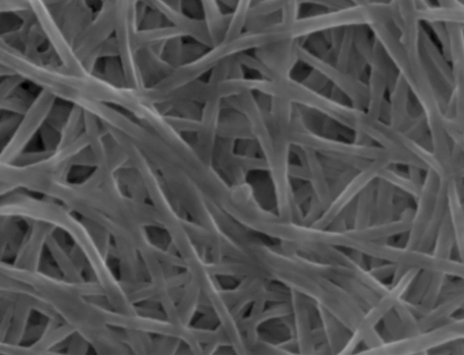
Fig. 1 Title of Fig 1.

Table 1. Title of Table 1.
Properties | RP | RO
Thermal conductivity [mW/m·K] | 20,42 | 19,82
Apparent density [kg/m³] | 37,7 | 43,8
Conclusions
The abstract should not exceed two A4 pages.
References
- Author A.; Author B: Abbreviation of Journal Title, Year, Volume(Issue) Pages
- Author A., Tittle of the Book, Publisher, Year, Pages.

