PROPERTY RENTAL ADVICE

1.- VISIT THE FLAT AND THE ROOM
We recommend not to pay any deposit or sign any agreement before having seen the flat.
BEWARE SOCIAL MEDIA AND FACEBOOK profiles where you need to deal with more than one person; Never pay an important sum of money as a deposit, NEVER PAY YOUR FIRST MONTH OF ACCOMMODATION without having seen the place.
During your visit, it is advisable to pay attention to:
- The general state of the flat and furniture
- Openings, spaciousness, humidity
- Street noise and neighbours
- Public transport options to the campus

2.-TENANCY AGREEMENT
- It is important to sign an agreement when renting: without this document, grievance or complaints will have no effect. Make sure you understand the content of the agreement you sign; your schoolmates, buddy… might be able to help you with words you don´t understand.

3.- DEPOSIT
- It is common to fix a 1-month deposit for tenants to hand out upon signature of the tenancy agreement. Your deposit will be given back in the terms established in the contract.

4.- EXPENSES
- In most cases, electricity, gas and water expenses will be on the tenants

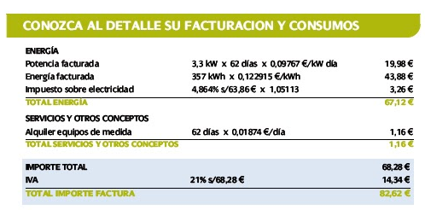 | Consumed electricity  Final Bill

Hence, even with a low consumption, taxes usually make bills rather high. We recommend to pay attention to your first bill, with a view to adjust your subsequent expenses.

5.-DAMAGE IN FURNITURE OR FITTINGS

- The agreement will probably include outline the repairs obligations of both parties. Most usually, furniture and contents deteriorated as a result of normal use can be repaired or replaced by the landlord. If damages are the result of the tenants’ negligence, they will need to cover for the cost of repair.

You should report any damage to furniture or fittings as soon as you detect them, within the first 2 weeks of the agreement in force. You should then both agree how any replacement or repair is to be arranged and how payment will be made.

6.-CONFLICT RESOLUTION

The Accommodation Service at the University of the Basque Country offers information on the available offer, but cannot act as an intermediate between tenants and landlords. Any disagreements or conflicts should be clarifies between both parties involved.

There is a public, official institution entitled to mediation in case of housing conflicto: BIZILAGUN. Please book your visit:

BIZILAGUN  VITORIA-GASTEIZ  2, Samaniego st.  01008 Vitoria-Gasteiz  Book your visit at ZUZENEAN office, 10 Ramiro de Maeztu st. Mon-Fri, 8am to 7.30pm (or dial 012) | BIZILAGUN  BILBAO  85, Gran Vía st, 1st floor  48011 Bilbao  Open Mon-Fri, 9am to 2pm. | BIZILAGUN  DONOSTIA-SAN SEBASTIÁN  13, Andía st. 5th floor  20005 Donostia  Open Mon-Fri, 9am to 2pm

