Dear partner,

it is a real pleasure for us to invite you to take part in our International Staff Training Week, which will take place at the University of Ferrara, between the 9th and the 13th of June, 2014.
Our initiative should be oriented to 2 main kinds of participants and will focus on the following themes:
- FOCUS GROUP A: International communication (max. 20 participants)
- FOCUS GROUP A: Reconciling work and family (max. 20 participants)
As well as offering a general framework programme for all of you, we would also like to offer you the chance to be involved in an enriching international and intercultural learning experience within your specific field of work.
Therefore you’ll have to select one of the two focus groups (Group A or B), in which you will have the chance to discuss particular subjects. Please note that if the number of participants to one focus group exceeds the limit, the International Office will have to decide how to balance the groups.
Furthermore, we invite all participants to prepare a presentation about a specific successful practice (in particular concerning GROUP B) to be shared during the Staff Week.
For your application we ask you kindly to fill in the following online-form by the 9th May, 2014:
http://www.unife.it/mobilita-internazionale/studiare-a-ferrara/international-staff-training-week-iii-edition
Attached you can find a draft of our programme.
Please note that all the costs related to travel, accommodation and food (with the exclusion of coffee breaks and the closing brunch) must be covered by the participants.
We are looking forward to hosting you in Ferrara!

Kind regards
Carlo Santoro / Silvia Pilot
- - - - - - - - - - - - - - - - - - - - - - - - - - - - - - - - - - -
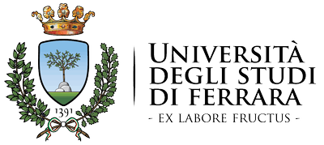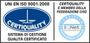
Ufficio Mobilità e Didattica internazionale
Università degli Studi di Ferrara
Via Savonarola, 9 - 44121 - Ferrara (Italia)
Tel: +39 0532 29 3176 / 3493 / 3028 / 3495
Fax +39 0532 29 3203
Webpage: Ufficio/Office - Unife International
Facebook: Ufficio/Office - Unife International

