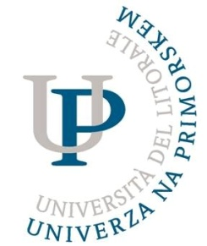

INTERNATIONAL WEEK AT THE UNIVERSITY OF PRIMORSKA
(SI KOPER03)

APPLICATION FORM

for teachers and administrative officers

Lifelong Learning Programme - Erasmus Exchange

Other Type of Exchange – please specify the type:

12nd– 16th May 2014

1. Personal data:
Full Name
(first name/family name)
Department
Position
Office contact details (e-mail address and phone number)
2. Home University:
Official Name
(in English)
Address

Name & contact details of Mobility Coordinator

3. Purpose of Attendance (please mark your selection):
Teaching mobility

Non-teaching mobility

In case of Teaching Mobility, please, fill in and forward the attached teaching programme to relevant Faculty Coordinator (see the contact list in Invitation Letter)

The participation to the International Week is free of charge. Travel and accommodation have to be covered by the participants. Participants can apply for Erasmus Staff mobility grant at their Home University.

If needed, we will select up to 25 participants (maximum of 2 participants per institution) for non-teaching mobility of the International Week privileging the participation of the staff working with Erasmus mobility.

The language of the training is English.

Date:
Signature of the Applicant

Date:
Signature and stamp of Home University’s Representative

Please return your application form by e-mail to
maja.vidmar@upr.si
or by fax to + 386-5-611-75-30
until Thursday, April 24th 2014!

Accommodation information
If you choose one of the following hotels for your accommodation placement during the International Week, discount prices are offered to you. When you contact the relevant hotel, please do not forget to mention that you are a participant of the International Week at the University of Primorska. For discount you need to contact the hotel directly, if you book your accommodation through booking sites, it is not necessary that the discount can be applicable.

IN KOPER:
1) HOTEL KOPER: http://www.terme-catez.si/en/slovenian-coast/accommodation-393/koper-hotel/
2) HOTEL BIO: http://www.hotel-bio.si/en
3) HOTEL VODIŠEK: http://www.hotel-vodisek.com/en/index.htm
4) GARNI HOTEL PRISTAN: http://www.pristan-koper.si/news/news.php?id=13

IN PORTOROŽ:
5) HOTEL MARKO: http://www.hotel-marko.com/eng/index.html

