Proceedings Template for Papers to EuroSoTL 2019
A. Author, B. Author, and C. Author, Affiliation
The full paper should be prepared using this template, and submitted both in doc/docx and pdf format in high quality print. No hardcopy is required. Please do not insert page numbers and do not secure the pdf file.
There are pre-defined text styles for all sections of the paper, which are described in section 3. Use them and do not adjust them!

Paper length, language and Submission
Paper length should be 1500 words for Posters (short paper) and 3000 words for oral communications (paper)
You can choose the language of the paper between English and the language in which you present your contribution. In ALL cases, the Abstracts must be written in English PLUS in the language in which the rest of the paper is written. Please proofread your paper.

Submission deadline and procedure
Please submit the full paper within the submission deadline Tuesday April 30, 2019, both in doc/docx and pdf format in high quality print to xxx.
E-mail subject: EuroSoTL 2019 full text.
Name of documents should be as follows:
- One author: LastnameAuthor.doc/docx/pdf
- Two authors: Lastname1Author_Lastname2Author.doc/docx/pdf
- More than two authors: Lastname1Author_etal.doc/docx/pdf

Proceedings from the conference
The articles will be collected in the Conference Proceedings in electronic format and available online on the conference page on https://www.ehu.eus/en/web/eurosotl-2019/home

General

Paper size, margins and numbering
Use page size A4. The text should fit exactly into the type area and be fully adjusted. Papers in two columns format will not be accepted. For A4 size paper the margin settings are: Top: 20 mm; Bottom: 20 mm; Inside: 25 mm; Outside: 25 mm. Table nn summarizes the margins applied.
Please do not insert page numbers.

Paper sections
After the title and author(s) and affiliation section, the paper directly starts with the Abstract (should not exceed 350 words and briefly summarize the essence of the paper), followed by the consecutively numbered main chapters. The abstract must be written at least in English, and in the case that the communication is presented and written in another language, then, write it also in that language.
Make sure you include methods, reflections and results. For further advice see the letter of acceptance. Include a list of references at the end of the manuscript.

Text styles and SECTION HEADINGS
There are pre-defined text styles for all sections of the paper. Use them and do not adjust them!
We have also listed the actual format of all pre-defined text styles below for those interested.

Title1
Format of the paper title: Centred Times New Roman 18 pt. Line spacing before and after the title is 24 pt and 12 pt, respectively.

Authors & Affiliation
Format of the author(s) and affiliation section: Centred Times New Roman 11 pt. Line spacing before and after is 0 pt and 24 pt, respectively. Make the affiliation italic.
Authors are listed with initials and last names, followed by the affiliation. If more than one line is needed, use a soft line break (shift return) to avoid any extra line spacing between the lines in the author(s) and affiliation section.

Abstract
Format of abstract: Same as Normal text style, but bold (see 3.6 below).
Always start the abstract section with the word "ABSTRACT:" in its English version, and “RESUMEN:” or “LABURPENA:” or “RÉSUMÉ: ”... depending on the language of choice. This word must be written in capitals.

Heading 1 (and Reference Heading)
Format of section headings: Bold capitals Times New Roman 11 pt. Line spacing before and after a heading is 12 pt and 6 pt, respectively. Use consecutive numbering of the sections. The References Heading is not numbered.

Heading 2
Secondary headings are as Heading 1 but typed with initial capitals. Line spacing before and after a secondary heading is both 6 pt. Please limit the depth of headings to major and secondary headings.

Normal text style
The normal text is typed in Times New Roman 11 pt, adjusted with single line spacing and fully adjusted (straight) margins. Line spacing between consecutive paragraphs within the same section is 6 pt as in this template. Do not insert extra empty lines between paragraphs.

Table & Figure description
Table and figure descriptions are: Italic Times New Roman 10 pt, adjusted with single line spacing and left margins. Line spacing between consecutive paragraphs within the same section is 6 pt as in this template. See examples in section 4.

References
Format of the reference section is: Times New Roman 10 pt, adjusted with single line spacing indented 0,7cm and fully adjusted (straight) margins. Line spacing between consecutive references is 3 pt as in this template. Do not insert extra empty lines between paragraphs. See examples in the Reference section of this template.

Lists, Figures and tables

Lists
Bullet lists and numbered lists are given the pre-defined text style List Paragraph (see the bullet list in section 1.1), which has the normal text style as a basis (Times New Roman 11 pt). List may be adjusted for indentation, margins and spacing depending on the context, but not for font and size.

Figures, diagrams, illustrations
Figures, diagrams, illustrations should have a resolution of 600 dpi. Reference to the figures must be given in the text. Two-column figure arrangement as shown in Fig. 1 and Fig. 2 is allowed: use 2x2 table without borders. The smallest font size in the figures shall not be smaller than 10 pt. The figure description text is 10 pt (see section 3.7 above).
 | 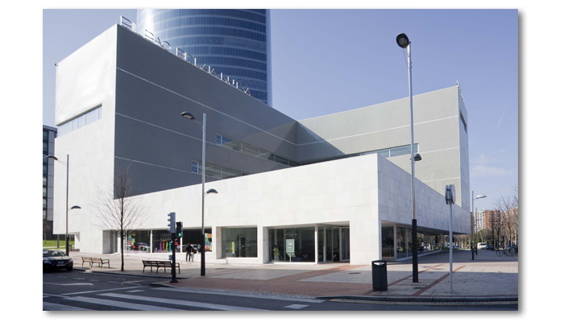
Fig. 1. Graphics | Fig. 2. Bizkaia Aretoa, Conference Venue

Tables
Tables prepared in basic word format are preferred. Tables must be referred to in the text in the format as Table nn. The smallest font size in the table shall not be smaller than 10 pt.
top | bottom | inside | outside
20 | 20 | 25 | 25
Table nn. Margins of the page size A4 [mm]
The table description text is 10 pt (see section 3.7 above).

summary, ACKNOWLEDGMENTS and references
Summary and acknowledgments are optional.
The reference style is optional but has to be consistent (Vancouver, Harvard, APA, ...). The reference section shall be given as follows:
References
[1] Lastname1, Initials, Lastname2, Initials, Lastname3, Initials and Lastname4, Initials (2009), Title of the article, Journal, Vol. 120, No. 6, pp. 1718-1731.
[2] Lastname5, Initials (2006), Title of the article, Proc. of the Conference, Editors, Place of Conference, Vol. 2, pp. 120-128.
or
Lastname1, Initials., Lastname2, Initials., Lastname3, Initials. and Lastname4, Initials. (2009). Title of the article, Journal, Vol. 120, No. 6, pp. 1718-1731.
Lastname5, Initials. (2006). Title of the article, Proc. of the Conference, Editors, Place of Conference, Vol. 2, pp. 120-128.
or
. . .

