ENLIGHT STAFF WEEK –October 13 to 15, 2026
DONOSTIA/ SAN SEBASTIAN

PRACTICAL INFO

VENUE:
Carlos Santamaria building (Campus Library) , located in the Campus of Gipuzkoa of the University of the Basque Country in Donostia/San Sebastian, is at easy walking distance from anywhere downtown.
Ignacio Mª Barriola, located in front of Carlos Santamaria Library (October 15th).

ARRIVALS:
The meeting starts on Thuesday, 13 October at 9:00. Please plan to arrive in Donostia/San Sebastian on the previous evening (Monday, 12 October. Please, note this is a public holiday in Spain).

PLANE: The main International Airlines have flights departing from/arriving at Bilbao (Loiu) airport, although direct flights might be difficult to find for some peripheral ENLIGHT partners.
The airport is very small; proceed to exit the arrivals lounge to access the taxi and bus stops (outdoors).
There are also other airports:
HONDARRIBIA /SAN SEBASTIAN: https://www.aena.es/en/san-sebastian.html
BIARRITZ https://biarritz.aeroport.fr/en/
VITORIA -GASTEIZ https://www.aena.es/en/vitoria.html
IRUÑA-PAMPLONA https://www.aena.es/en/pamplona.html
BILBAO https://www.aena.es/en/bilbao.html
From airport by bus:
From Hondarribia airport to Donostia/San Sebastian (30 min. approximately) https://ekialdebus.eus/es/linea-e21-aeropuerto-hondarribia-donostia/
From Bilbao airport to Donostia/San Sebastian (1h:15 min. approximately) https://online.pesa.net/Index.asp?id=en
From Biarritz airport to Donostia/San Sebastian (45 Min. Approximately) https://www.alsa.com/en/coach
From Vitoria-Gasteiz airport to Donostia/San Sebastian (1h:30 Min. Approximately) No direct transport from airport https://www.alsa.com/en/coach
From Iruña-Pamplona airport to Donostia/San Sebastian (1h:30 Min. Approximately) No direct transport from airport https://www.alsa.com/en/coach

TRAIN: for closer partners (Bordeaux and to a lesser extent Ghent), train connections might be an option in case the travel is done during the week-end.
French TGVs departing from Paris (also Bordeaux Saint-Jean) arrive in Hendaye (last French city before the border); Donostia-San Sebastián is connected to Hendaye through the EUSKOTREN commuter (45 minutes).

ACCOMMODATION:
Donostia/San Sebastian is quite compact; easy connections anywhere in the centre waking or by bus
The recommended hotel is within a 25-30 minute walk from the train station in Donostia /San Sebastian. For local transport the website is a great guide. Tickets for the bus can be purchased with a credit card /cash on the bus.
We have made a pre-booking in Olarain residence for participants of the Staff Training Week, (check-in October 13th, check-out October 15th). This accommodation is simple, yet convenient and very close (5-minute walk) to Carlos Santamaria and 7-minute walking distance to Ondarreta beach.
ACCOMMODATION ONLY
• Single room: €63.00 (VAT included)
• Double room: €76.50 (VAT included)
• Superior double room for single use: €85.50 (VAT included)
ACCOMMODATION AND BUFFET BREAKFAST
• Single room: €77.50 (VAT included)
• DUI: €91.00 (VAT included)
• Superior double room for single use: €100.00 (VAT included)

How to book:
Please send an email to: javiermarin@olarain.com
Use booking code: Enlight26 Please note that online booking with the code is not possible.
Booking deadline: 15 August 2026
Accommodation costs are covered by participants.
CLIMATE:
The Basque Country enjoys gorgeous landscapes, partly due to the high pluviometry levels all year long. Temperatures are usually mild, although visitors should not expect weather or temperatures as warm as in Southern Spain. October is notoriously unreliable in terms of weather.
Average minimum and maximum October temperatures in Donostia/San Sebastian: 13° - 19°

SIGHTSEEING:
Donostia/San Sebastian is famous for its elegant beaches and gastronomy. The highlight is La Concha Bay, perfect for walking, swimming, or enjoying scenic views. You can climb Monte Igeldo or Monte Urgull for panoramic views of the city and coastline. The Old Town (Parte Vieja) is ideal for exploring narrow streets and tasting traditional pintxos. Don’t miss the Peine del Viento sculpture by Eduardo Chillida and the sculptures by Jorge Oteiza, which reflect the city’s strong connection to modern Basque art, located at the edge of the sea. The city also hosts the renowned San Sebastián International Film Festival each year.

PINTXO (small appetizer, quite similar to Spain´s renowned Tapas)
Gilda: It is considered the original pintxo of Donostia. Salty, tangy, and slightly spicy, it perfectly represents the bold flavors of Basque cuisine.  A small skewer made with green olives, anchovies, and pickled green peppers (guindillas). | 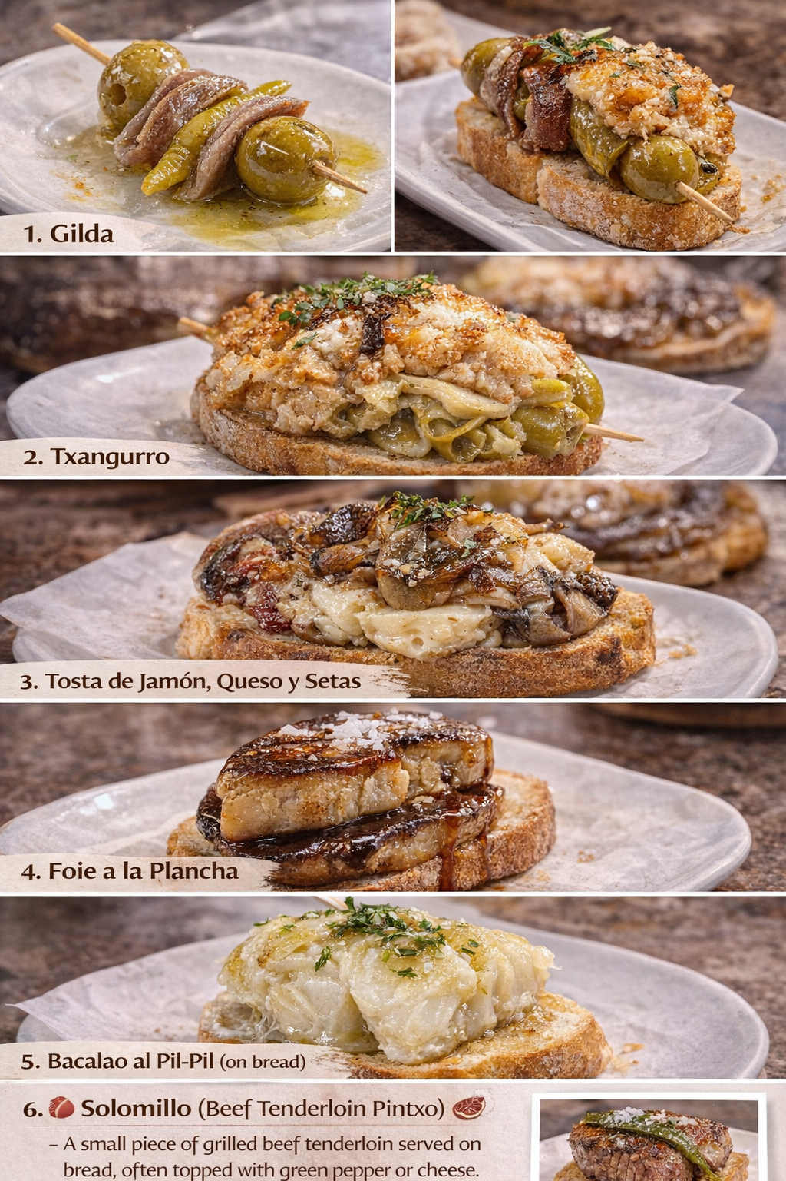
Tortilla de Patatas A small slice of the classic Spanish omelette made with eggs, potatoes, olive oil, and sometimes onion, served on a piece of bread.  Tortilla de Bacalao. A fluffy omelette made with salt cod (bacalao), eggs, sautéed onions, and sometimes green peppers, typically served in generous slices. | 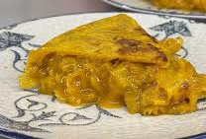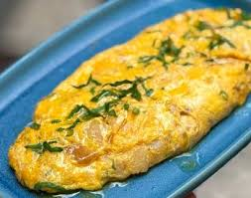
Txangurro Spider crab meat mixed with onion, tomato, and brandy, usually baked in the crab shell and sometimes served on bread. | 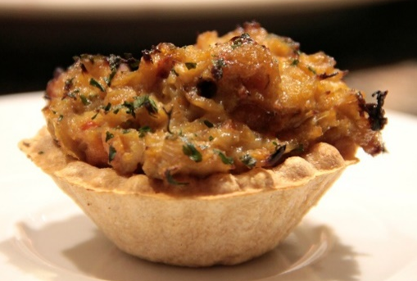
Tosta de Jamón, Queso y Setas Toasted bread topped with jamón ibérico, melted cheese, sautéed mushrooms, and caramelized onions.
Foie a la Plancha Seared foie gras served on toasted bread, often with a sweet reduction sauce. | 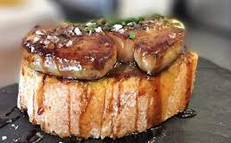
Bacalao al Pil-Pil (on bread): Salt cod cooked in olive oil with garlic, creating a creamy emulsified sauce, sometimes served as a pintxo. | 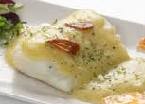
Solomillo (Beef Tenderloin Pintxo) A small piece of grilled beef tenderloin served on bread, often topped with green pepper or cheese. | 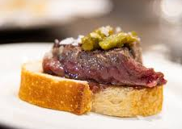

HAVE A SWEET TOOTH?
Pantxineta: A classic Basque Country dessert made with puff pastry filled with rich custard cream and topped with almonds. It’s traditionally served warm so the creamy interior is soft and comforting. | 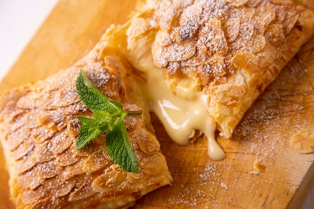
Basque Cheesecake An ultra-creamy, crustless cheesecake with a caramelized top and soft, custard-like center.  Created in 1988 at the bar La Viña in Donostia and now famous worldwide | 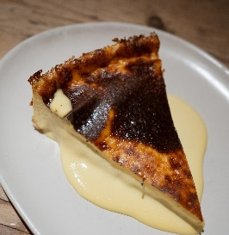
Basque cake: Shortcrust pastry usually filled with pastry cream.  Originally from the French Basque Country (Saint Jean de Luz, Biarritz…), widespread in the Southern side of the border as well | 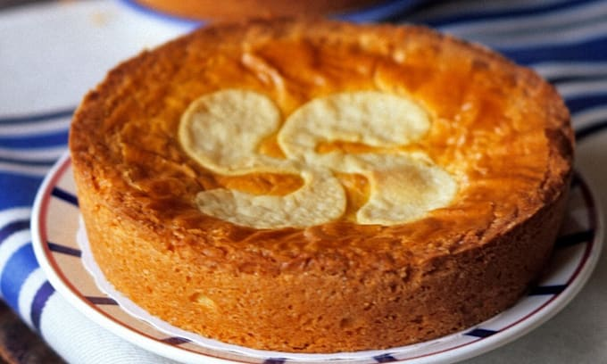
Brioche: A fluffy, “swee, butter-filled brioche” with a glazed, sugar-topped top | 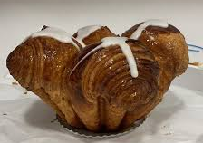
Churros & Other Sweet Treats: Churros served with rich hot chocolate are a classic café treat you’ll find in Donostia bakeries and cafes. | 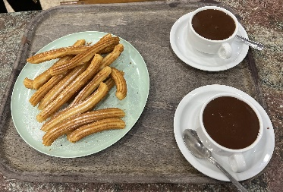
Ice Cream in a Cone: Is a classic and very popular dessert in Donostia-San Sebastián, especially during the warmer months. In Donostia, you can find high-quality artisan gelato shops offering traditional flavors like vanilla, chocolate, and strawberry, as well as local specialties such as cheesecake, yogurt, or seasonal fruit flavors. | 

BUSINESS AND SHOPPING HOURS
Except for pastry shops, grocery stores and International franchises, shops tend to close for lunch.
Usual opening hours: 10am to 1pm – 4pm to 8pm

FURTHER INFORMATION OR SPECIAL REQUESTS:
Please, contact enlight@ehu.eus for more detailed information or specific requests for any ENLIGHT guest.

Electricity
C and F type electrical plugs.

Currency
Euro

Contact:
For questions please contact enlight@ehu.eus

