Geology and Geodiversity
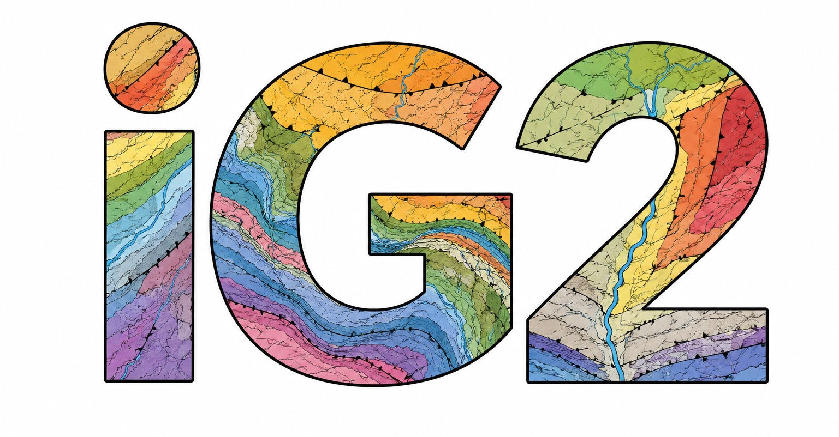
Contact in the Faculty of Pharmacy (Name, e-mail): Benito Ábalos (benito.abalos@ehu.eus)
Website link: currently not available
Area(s) of science: Geology, Geodynamics, Environmental Sciences and Technologies

Key words: | Geology, Geodynamics, Tectonics
We are faculty members from the Faculty of Pharmacy with decades of research experience (belonging to established EHU and IKERTALDE2026 research groups alongside academic staff from other centers, and boasting a long track record of projects funded through competitive calls). We are part of the Mapping Service (SGIker), collaborating on geological mapping projects for public administrations using LiDAR technology. We have authored numerous articles in international scientific journals applying advances in knowledge to areas such as energy and mineral resource exploration, the geological interpretation of regional seismicity, the design of geological reservoirs (for gas or hydrogen storage), and reconstruction of the regional geomorphological evolution during the Quaternary. We also conduct Geology outreach activities (speachs and field trips) for various organizations and associations.

Research lines
1: LiDAR-supported geological mapping
2: Energy resources exploration
3: Strategic and critical metal resource exploration
4: Energy transition
5: Underground energy resource storage
6: Global change

Equipment
Specialized computer equipment (Geographic Information Systems)
Historical cartographic and aerial photograph databases

Members of the group |  | Departament | Centre
IP | Benito Ábalos Villaro | Geology | Fac. Pharmacy
CoIP | Fernando Sarrionandia-Ibarra Eguidazu | Geology | Fac. Pharmacy
 | Pablo Puelles Olarte | Geology | Fac. Science and Technology
 | Iván Martín Martín | Geography | Fac. Arts
Other researchers | Aitor Aranguren Iriarte | Geology | Fac. Science and Technology
 | Néstor Vegas Tubía | Geology | Fac. Science and Technology
 | Iván Asensio Cantero | Geology | Fac. Science and Technology
 | José Julián Esteban Guzmán | Geology | Fac. Science and Technology
 | Julia Ana María Cuevas Urionabarrenechea | Geology | Fac. Science and Technology
 | Jon Errandonea Martín | Geology | Fac. Science and Technology
 | Encarnación Roda Robles | Geology | Fac. Science and Technology
 | Idoia Gárate Olave | Geology | Fac. Science and Technology
Picture of the research group located at the Faculty of Pharmacy:
